Create Social Login with Spring MVC

យើងមាន Resource Server ដែលអាចអោយ Client ធ្វើការចូលបាន ដោយ http request: one is public and private the user need to login with Authentication Server to Access.
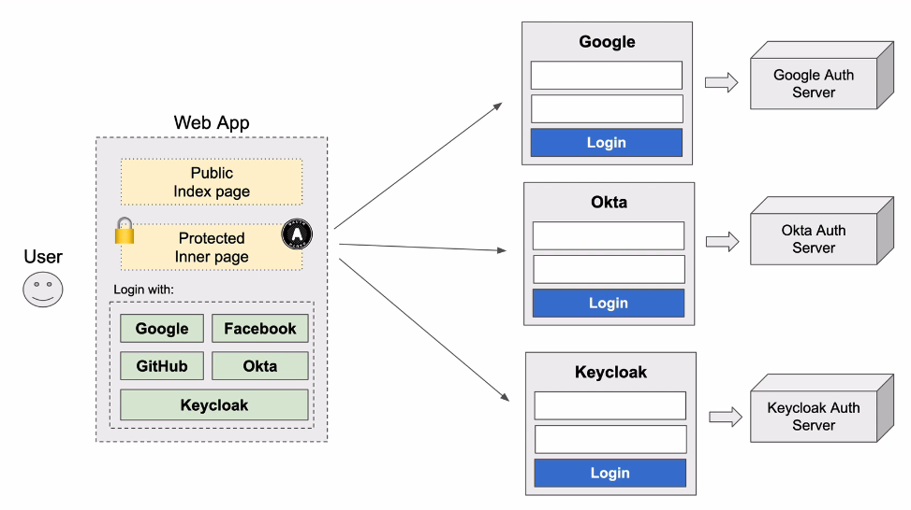

- Create SocialLoginApp
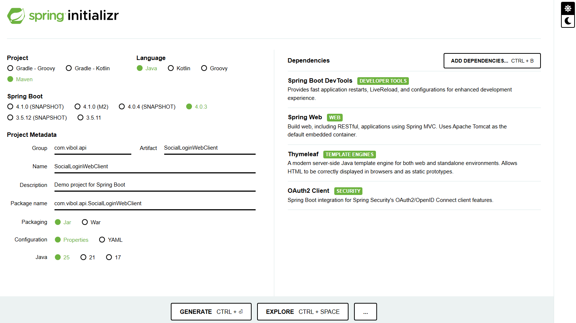

- Create Controller:
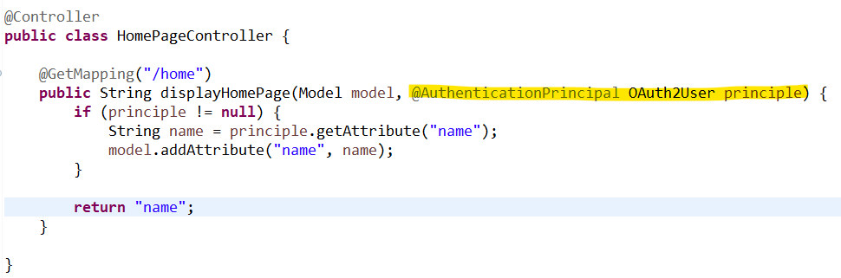

- First injection: @AuthenticationPrincipal OAuth2User principle
ដើម្បីធ្វើការដាក់ Security when user request to this API
- Second : Model model : បង្កើតបោះទៅអោយ Template viewer
តាមរយៈ name ដែលបានមកពី JWT យើងយកវាទៅបង្ហាញនៅក្នុង Template
model.addAttribute("name", name); យើងបោះ parameter នឹង name ទៅអោយTemplate.

// html template that we will create: home.html
return "name";
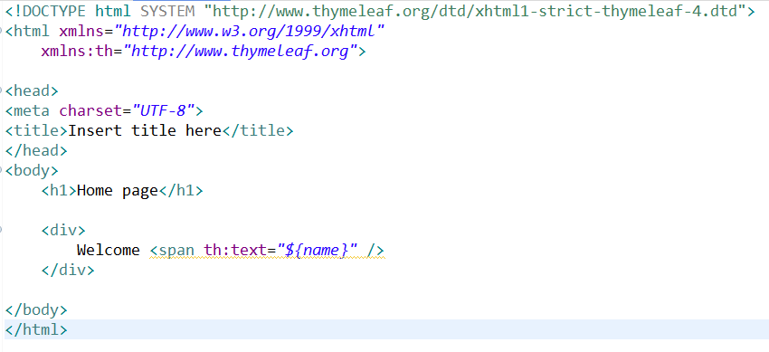

<!DOCTYPE html SYSTEM "http://www.thymeleaf.org/dtd/xhtml1-strict-thymeleaf-4.dtd">
<html xmlns="http://www.w3.org/1999/xhtml"
xmlns:th="http://www.thymeleaf.org">

<head>
<meta charset="UTF-8">
<title>Insert title here</title>
</head>
<body>
<h1>Home page</h1>

<div>
Welcome <span th:text="${name}" />
</div>

</body>
</html>

2-1 public url
បង្កើត controller for public access then they can click got to home page.

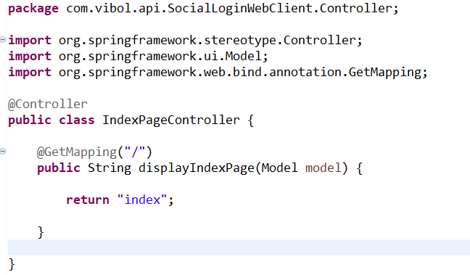

Template: index.html
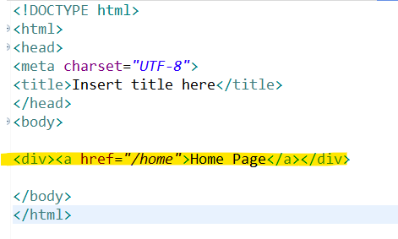

- Create Security Filter class from WebSecurityConfiguratinAdapter

